A – REQUEST FOR SERVICE (To be completed and sent to SOFRASER)
A1 - CUSTOMER
Company^{(*)} |  |  |  |  |  |  |  |  |  |  | Customer type |  |  |  |  | ☐ Distributor ☐ End user
Address |  |  |  |  |  |  |  |  |  |  | E-Mail
 |  |  |  |  |  |  |  |  |  |  | Phone
A2 – EQUIPMENT
Sensor |  | ☐MIVI ☐PIVI ☐SOFAST ☐SOF……… ☐OTHER……………………………………………………………………………….
Electronic |  | ☐6000 ☐ 7000 ☐8000 ☐9200 ☐9500 ☐9600 ☐9700 ☐9200 ☐9800
Serial number^{(*)} |  |  |  |  |  |  |  |  |  |  |  |  |  |  | Purchase date
A3 –REQUEST^{(*)}
☐ Periodic calibration |  |  | ☐ Expertise at SOFRASER |  |  |  |  |  |  |  |  | ☐ Maintenance / Repair |  |  |  |  | ☐ On site servicing
A4 - DEGREE OF URGENCY
Average processing times after receiving the equipment and order:
- 1-2 weeks for a scheduled calibration
- 3-4 weeks for unscheduled calibration or simple maintenance
- More than 4 weeks for complex maintenance or requiring special components
Do you have a spare equipment? |  |  |  |  |  |  |  | ☐ Yes ☐ No
Do you need a spare equipment? |  |  |  |  |  |  |  | ☐ Yes to buy ☐ Yes to rent ☐ No
A5 – SENSOR CLEANLINESS^{(*)}
A sensor must return decontaminated to be calibrated, appraised or maintained. If this is not the case, a cleaning service will be charged taking into account the difficulty of cleaning and this can increase the time of expertise. To facilitate cleaning and to ensure the safety of our teams, it is necessary to specify the names and families of products on the sensor as well as the usual cleaning method (which solvent to use?).
The sensor is decontaminated |  |  |  | ☐ Yes |  | If Not |  |  | Products
 |  |  |  |  |  |  |  |  | Cleaning method
A6 – VALIDATION OF THE REQUEST^{(*)}
Date |  |  |  |  | Name and First Name
B - AUTHORIZATION TO SHIP (Given by SOFRASER)
RMA Number  (To be legibly marked on the packaging) |  |  |  |  |  |  |  |  |  |  |  |  | Recommended value for the customs declaration
See reverse side precautions to return the sensor and its electronic and put a copy of the complete document in the package
(*) Mandatory
C – PRECAUTION TO RETURN THE SENSOR AND ITS ELECTRONIC
Transportation damage will not be covered by warranty. To avoid this it is important to pack the equipment correctly
- Without specific authorization, it is necessary to return the sensor and its electronics

- Choose a cardboard or box adapted in size and strong enough (Ideally the original cardboard packaging that is particularly suitable)
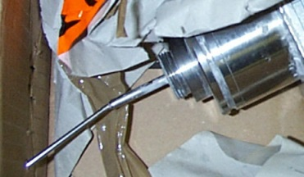
- Always screw the protecting tube to the sensor in order to protect
the vibrating rod – If you don’t have it, please ask one to Sofraser before
shipment (Repair cost if damaged: minimum 2000 €)
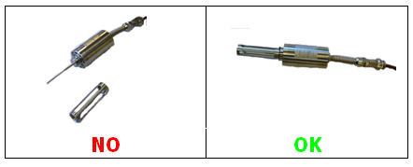

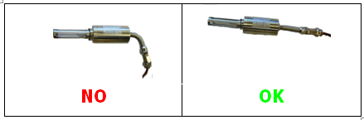
- Do not bend more than the minimum radius of curvature the cable and flexible tube

- Protect the sensor and the flexible tube
- Protect the cable
- Protect the electronic device
- Wedge the sensor, the cable and the electronic device in the parcel in order to avoid movements inside the parcel
D – TREATMENT AT SOFRASER
- Reception at SOFRASER
- Transfer to the after-sales workshop service (the RMA number facilitates dispatching).
- Equipment expertise
- Writing and sending the offer including the expertise (average time 2 to 5 days after receipt)
- Start of maintenance upon receipt of order or bond for agreement

